**Intuitive definitions**

*Phonons:* In liquids and dielectric solids, heat is primarily transferred by atomic vibrations that give rise to lattice waves, usually modelled as quasi-particles called phonons. As phonons cannot be tracked in a literal sense, we instead track the frequencies of the atoms involved in heat transfer to deduce the frequencies of corresponding phonons.

*Vibrational Density of States (VDOS):* Obtained via a Fourier transform of the velocity auto-correlation function. This measures the permissible frequencies and intensities of vibrational modes for phonons to occupy .We calculate both interfacial and bulk VDOS for both solid and liquid atoms. Thus there are 4 possible VDOS measurements: interfacial solid, bulk solid, interfacial liquid, and bulk liquid.

*Spectral decomposition of heat flux (SDHF):* Obtained via a Fourier transform of the force-velocity cross-correlation (FVCF) function. Roughly can be thought of as the effective heat carriers in a medium i.e. the modes engaged in heat transfer, and their relative contribution to the total energy transport. We only calculate **interfacial** solid and **interfacial** liquid SDHF separately. Therefore the “solid SDHF” in our results corresponds to the phonon frequencies sent out by interfacial solid atoms, while ”liquid SDHF” in our results corresponds to phonon frequencies received by interfacial liquid atoms.

*Mode Engagement Overlap (MEO):* This measurement quantifies the overlap between VDOS and SDHF, and can be *separately calculated* for both **interfacial solid** and **interfacial liquid** atoms, respectively. Note that as we don't have SDHF plots for **bulk** solid/liquid, we cannot calculate MEO values for the bulk regions. We propose that the MEO measurement can be understood to be the *relative* reliance by the phonons on a subset of the available frequency spectrum when transporting heat across the interface. In plain words, VDOS summarises the available frequencies, SDHF shows the ones being used, and MEO quantifies that usage, thus quantifying a kind of “heat transfer efficiency” from the solid’s perspective.

Note that the MEO is nearly-perfect in the interfacial liquid, as SDHF and VDOS plots overlap almost exactly. So when we discuss MEO below, we focus on the interfacial solid atoms only, where wettability plays a role.

comment

*Solid/liquid SDHF Overlap (SL-SDHF)*: This measurement quantifies the overlap between the SDHF for the interfacial solid and interfacial liquid atoms. Thus there is only 1 possible SL-SDHF calculation per simulation unlike MEO (2), SDHF (2) and VDOS (4). We propose that the SL-SDHF o(it improves on the SL-VDOS overlap which is commonly used in the literature)verlap quantifies a different kind of efficiency, this time for the liquid to receive phonons from the solid

Upon the introduction of a virtual interface, SDHF can be computed in a bulk solid, both to the left and to the right of the interface. Seeing as the interface is fictitious i.e. the media are identical on either side, the SDHF_left = SDHF_right, intuitively. This describes the modes engaged in bulk solid heat transfer, and per our proposed metric, this entails 100% SDHF overlap. However, counterintuitively, this does not represent 100% elastic heat transport! Zhou 2017 showed that we underestimate energy transport in a bulk solid significantly if we only account for 2-phonon (elastic) scattering. This shows that, despite SDHF overlap being perfect, inelasticity can still exist, meaning modes split/combine to lower/higher frequencies, even within a solid. We can expect this extends to a solid liquid interface with near perfect SDHF overlap. In other words, if there is a peak of equal intensities at one frequency present in both the solid and liquid SDHF, this does **not** necessarily mean that this mode passes through elastically, contrary to our previous discussion.

Further consulting solid-solid literature, Xu 2022 studied an LJ-LJ solid-solid interface with a mass ratio of 4. It was found that, at ultra-low temperatures (2K), SDHF_left = SDHF_right, despite the vast vibrational mismatch. These spectra were almost identical to the spectral heat-flux distributions obtained using harmonic approximations, meaning the heat-transfer at this interface is perfectly elastic near 0K. This is in line with previous studies.

With increased temperatures, vibrational amplitudes become increasingly large, and we begin exploring more anharmonic portions of the interaction potential, leading to inelasticity. This is what gives rise to the difference in the left SDHF and the right SDHF.

In essence, what we are saying is that when temperature = close to 0K, sdhf overlap is near 100%, and heat transfer is elastic. However, in the case of the bulk solid, at temperatures above roughly 50K, sdhf overlap is 100%, yet heat transfer is not fully elastic. As such, we can say that we cannot decisively conclude the nature of elasticity using sdhf overlap… so I am not certain what this means physically.

Instead, from our results, we notice that as wettability increases, the solid-liquid SDHF overlap increases. The spectra initially do not resemble each other at all, and as eps tends to maximum, the spectra almost overlap perfectly. This could be indicative of a transition to bulk-like solid conduction. This can also be seen in our VDOS plots, where the interfacial solid begins vibrating in an almost bulk-like fashion. Question to be answered: does a bulk solid have MEO 100%? If not, then our inflection point in the MEO vs Eps plot could be indicative of the transition from solid-liquid to solid-solidlike transfer, coinciding with the cross-over observed in SDHF overlap vs Eps.

*This isn't exactly right

**Main result**

The main result of this Letter, showing that there is a distinct change in slope of G vs epsilon at 0.04 eV (Fig 1, top).

We think this crossover results from two distinct mechanisms:

1. The ‘efficiency’ of the solid’s ability to send phonons out increases with wettability up to 0.04 ev, as quantified by the MEO overlap (Fig 1, center). Beyond that it levels off, and then decreases until 0.1 ev.
2. The ‘efficiency’ of the liquid’s ability to receive phonons from the solid increases linearly with wettability throughout the epsilon range, as quantified by the SL-SDHF overlap (Fig 1, bottom).

1. and 2. taken together explain the crossover as both solid-side and liquid-side mechanisms contribute to interfacial conductance, but the solid-side mechanism drops off beyond 0.04 ev, which lowers the efficiency of the overall heat transfer beyond 0.4 ev. This happens because the VDOS (see Fig 2) gets right-shifted to higher frequencies that are not accessible to phonons. Fig 3 decomposes the MEO overlap into respective longitudinal and transverse MEOs, showing that both drop off, but transverse modes display the exact crossover threshold (which makes sense). Mcomment

Questions:

1. SDHF trails behind VDOS - why?
2. VDOS overlap is not accurate measure of G because SDHF doesn’t keep up? Shown by crossover
3. Why does G keep increasing beyond peak MEO overlap?

As epsilon increases, MEO in the interfacial solid rises to a maximum (approaching the bulk MEO), then plateaus and falls off. With increasing epsilon, in the interfacial solid, low frequency modes are damped, and high frequency modes are enhanced/created. The solid SDHF follows a similar trend, incurring a right-shifting of the spectrum, with higher frequency modes contributing more and more to interfacial energy transport. Beyond the MEO inflection point, however, the VDOS continues the same trend of enhancing high frequency modes, and damping low frequency modes, while the SDHF ‘lags’ behind the VDOS, being unable to fully utilise the new high frequency modes that are being created; seeing as the heat-flux is equal in all cases run, this means the low-mid frequency modes are being ‘over-engaged’/‘over-utilised’ in order to ‘make up’ for the ‘under-utilisation’ of high-frequency modes.

At the same time, with increasing epsilon, the solid-liquid SDHF overlap is increasing. (is it linear increase or is there a cross-over here as well? need to sort out issue with loglog scale plot.). When SDHF overlap is low, we cannot distinguish whether energy being transported at frequencies common to both spectra is elastic or inelastic. Energy transported beyond the cutoff of the receiving side must, by definition, be inelastically redistributed. When overlap is high, it becomes increasingly difficult to distinguish whether energy is transported elastically or inelastically, because inelastic transmission can occur even when a mode exists on both sides. Nonetheless, for the sake of this discussion, let us assume that our intuition is true: despite our inability to quantify it, with increasing SDHF overlap, elasticity is likely increasing.

Putting the trends of MEO and SDHF together: when SDHF overlap is low, inelasticity is likely high. As epsilon increases, mode transmission is enhanced across the board, because these modes are then redistributed inelastically into the fluid, meaning mode enhancement does not necessarily have to occur at a particular frequency range. This leads to an increase in MEO, as

crucial assumptions made:

sdhf overlap and elasticity and directly correlated

there exists a crossover in the s-l sdhf overlap plot

the low-mid high frequencies being overengaged in the solid are the ones that are elastically transported to the fluid, because that is where the mode availability is on the receiving side.

Things that must be done to add validity to these claims:

consult solid-solid literature for theory on predicting elasticity, and whether elasticity/inelasticity is a good predictor of G.

correct sdhf plot to make loglog to see if crossover exists

see if the low-mid freq modes that are being over-engaged in the solid sdhf at high wettabilities indeed correspond to the frequencies seen in the liquid VDOS/SDHF?

ps: this adds validity to our claim that vdos overlap cannot capture all aspects because it assumes pure elasticity across the entirety of the wettability range, where as elasticity is perhaps most dominant when epsilon is high?

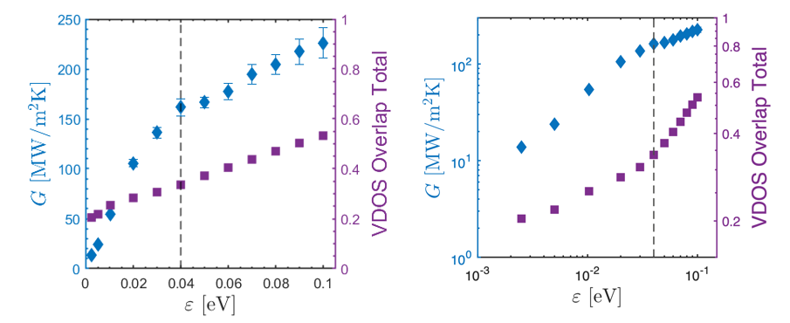

Fig 1. G vs Epsilon Vs VDOS overlap: plotted on a linear and log scale, demonstrates crossover clearly, and shows how vdos overlap is unable to capture the G plateau

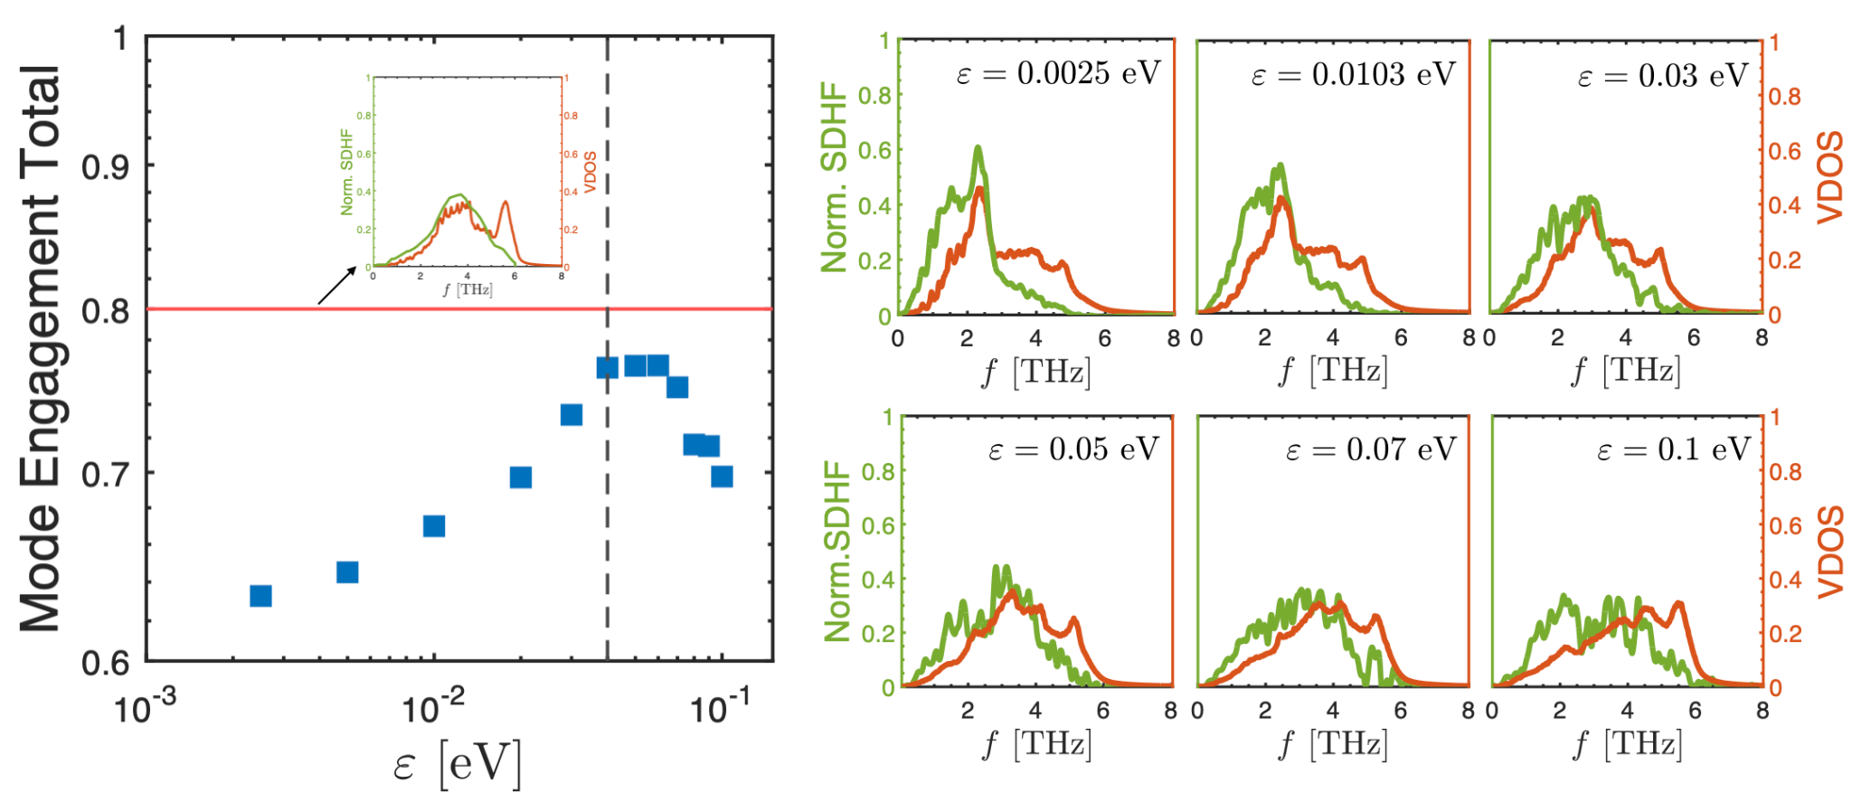

**Fig 2. Mode engagement overlap, with panel plots of 6 wettabilities demonstrating convergence and divergence of MEO**

**Inset shows bulk solid MEO, which is potentially a hypothetical “maximum” for the solid?**

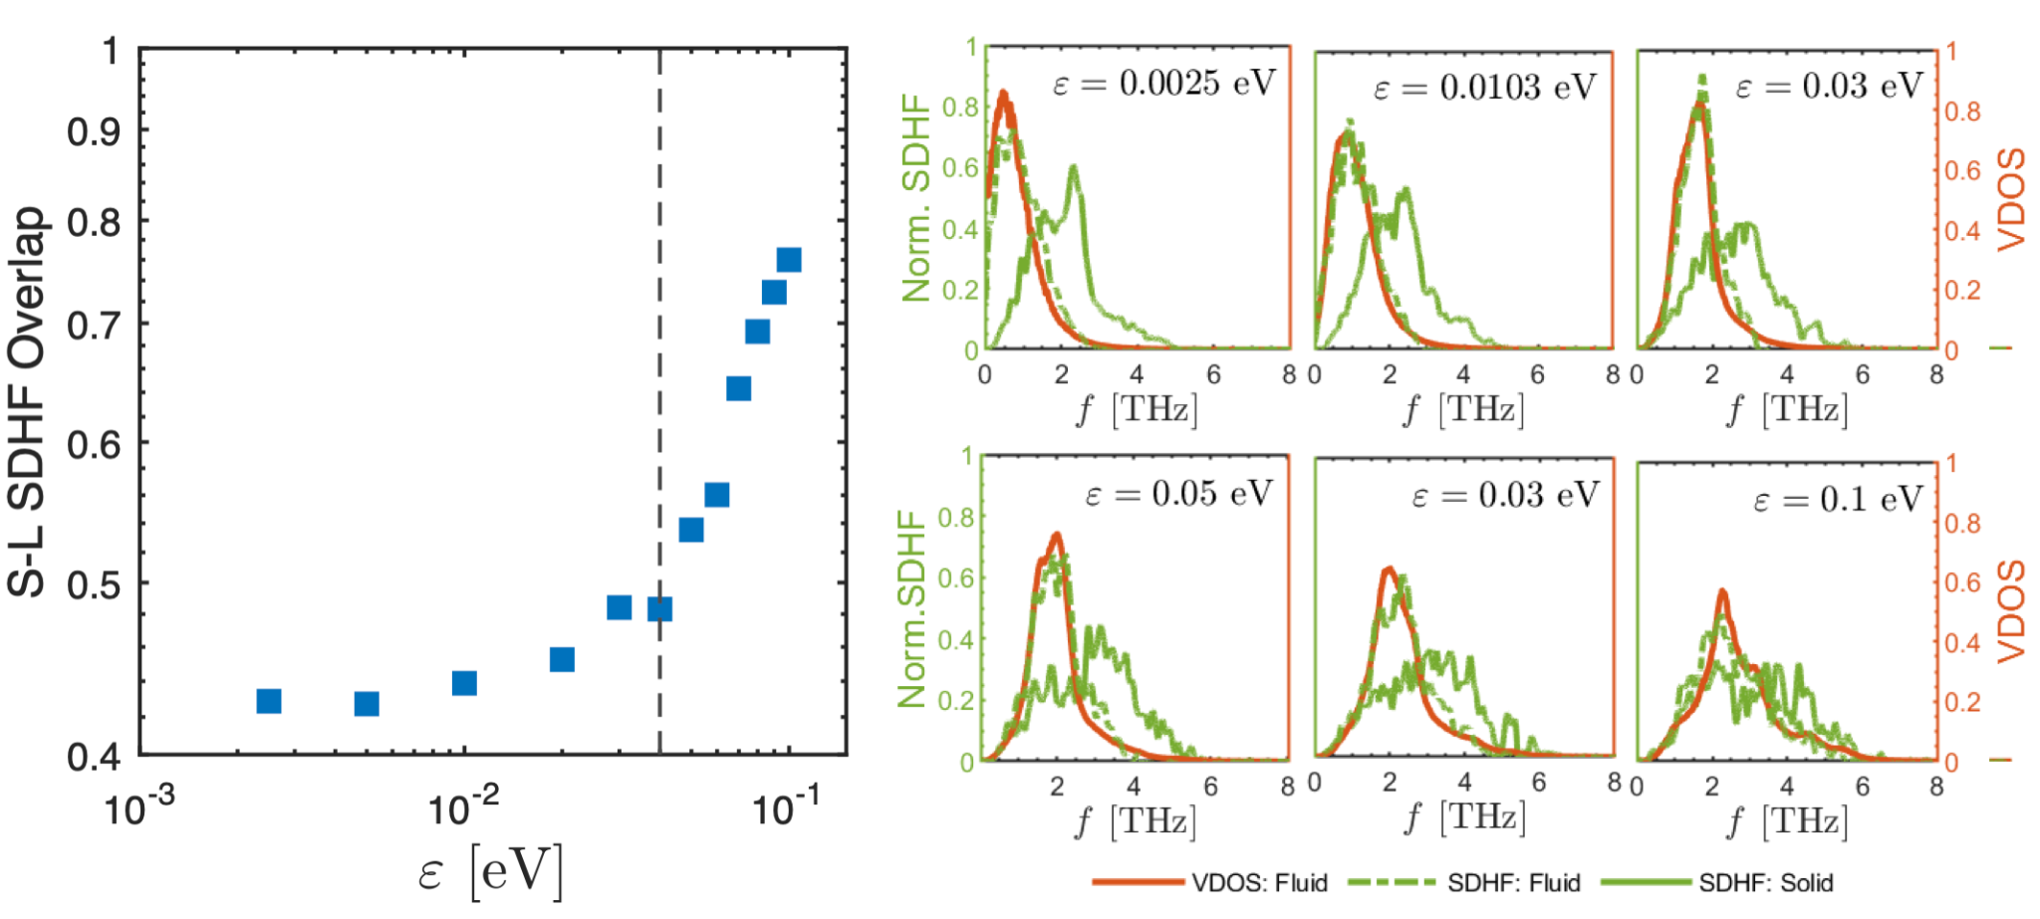

**Fig. 3: solid-liquid sdhf overlap (left) derived from panel plots(right). Panel plots demonstrate how liquid sdhf tracks its vdos, and how overlap is more highly dependent on wettability post crossover**

In this plot of S-L SDHF, we know for a fact that: the liquid SDHF is approximately equal to its VDOS, and the solid SDHF approaches its VDOS until 0.05 then diverges.

Until 0.03 eV, the liquid’s spectra (both vdos and sdhf, since we are saying they are roughly identical across the wettability range) are rightshfting and increasing in peak magnitude. At the same time, the solid’s SDHF is approaching its VDOS, increasing the MEO. Assuming there is a cross-over in the S-L SDHF plot, at this stage until 0.04 eV, the increase in S-L SDHF overlap is small. Both spectra appear to be rightshifting in approx equal increments, meaning overlap area is not significantly enhanced.

Beyond this point, the liquid’s spectrum begins rightshifting farther than the solid SDHF: it broadens and softens its spectra. It is interesting to note that the solid SDHF continues to right-shift, as we have seen in the heat-flux accumulation plots. The sending side spectra are affected by the liquid’s presence, but they are still driving the heat transfer: the liquid side simply “moulds” itself to the solid side.

**Other results**

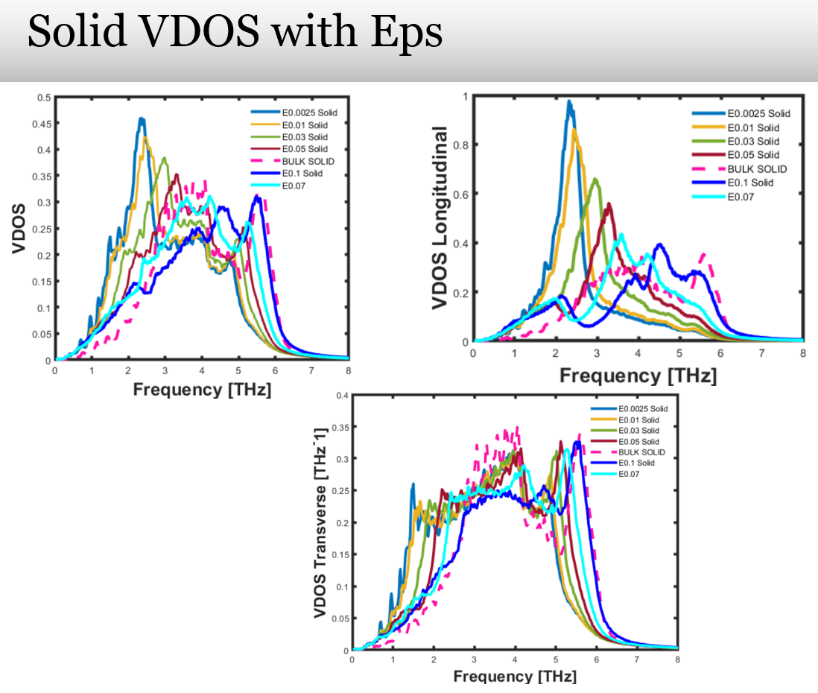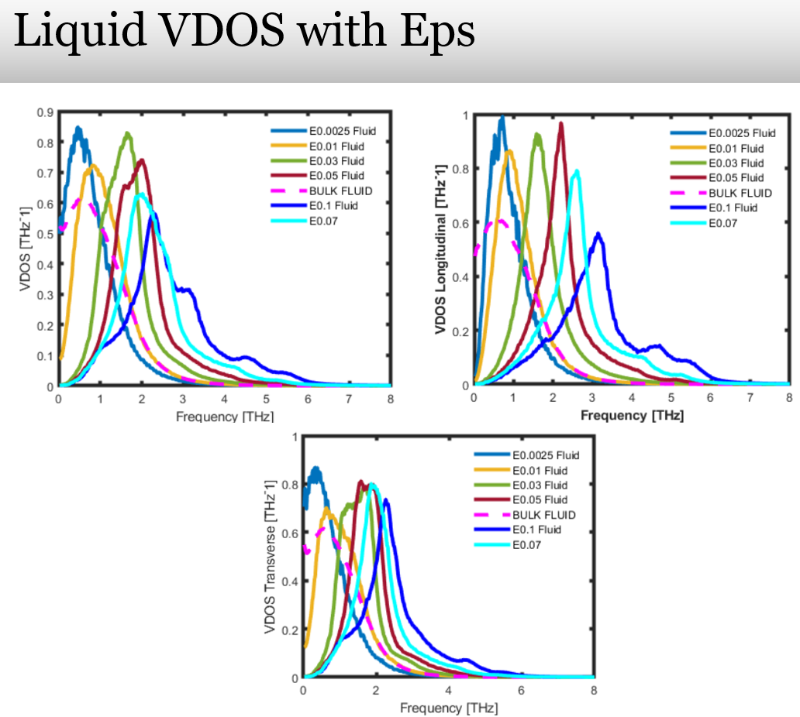

**Fig 2: (left) Interfacial solid VDOS (bulk solid in dashed lines) for all wettabilities; (right) Interfacial liquid VDOS (bulk liquid in dashed lines) for all wettabilities**

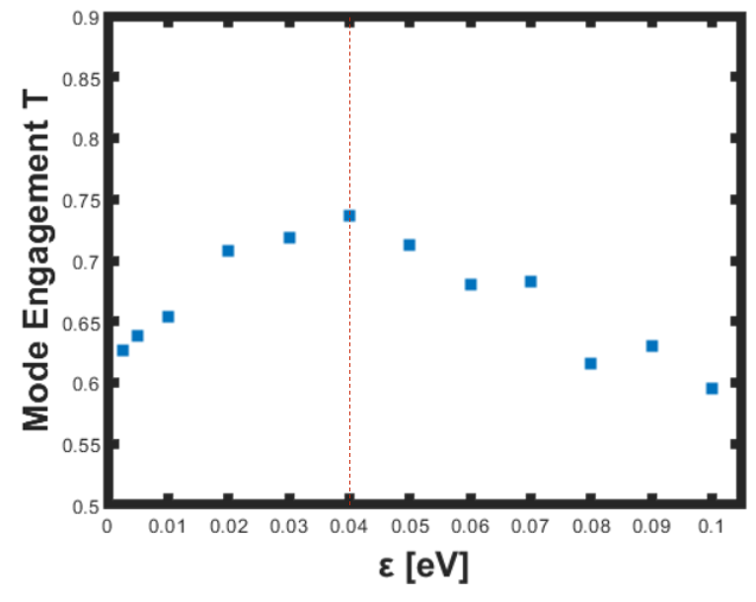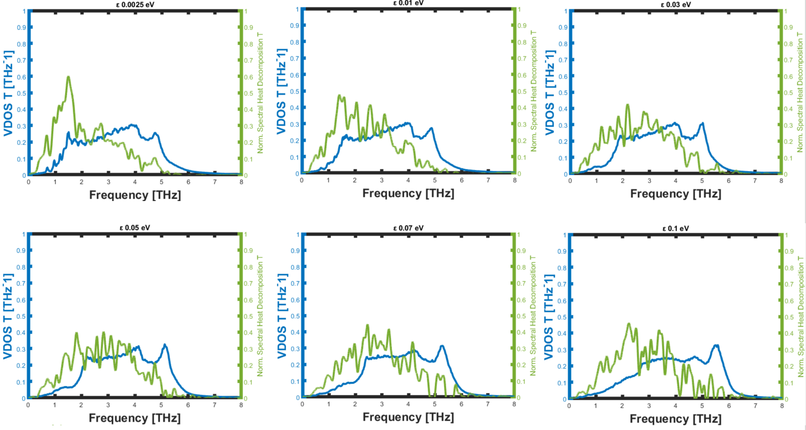

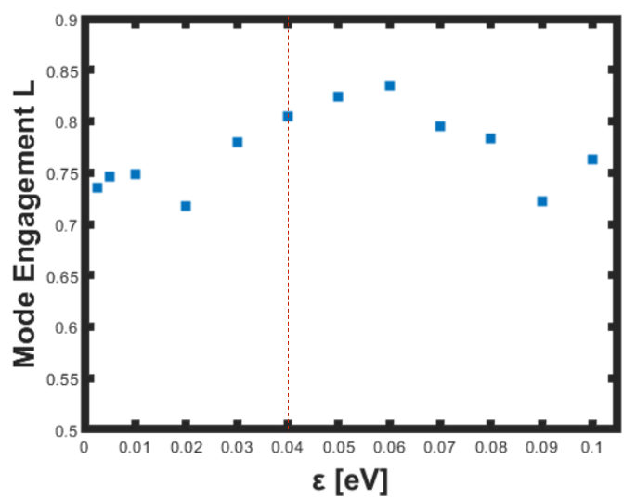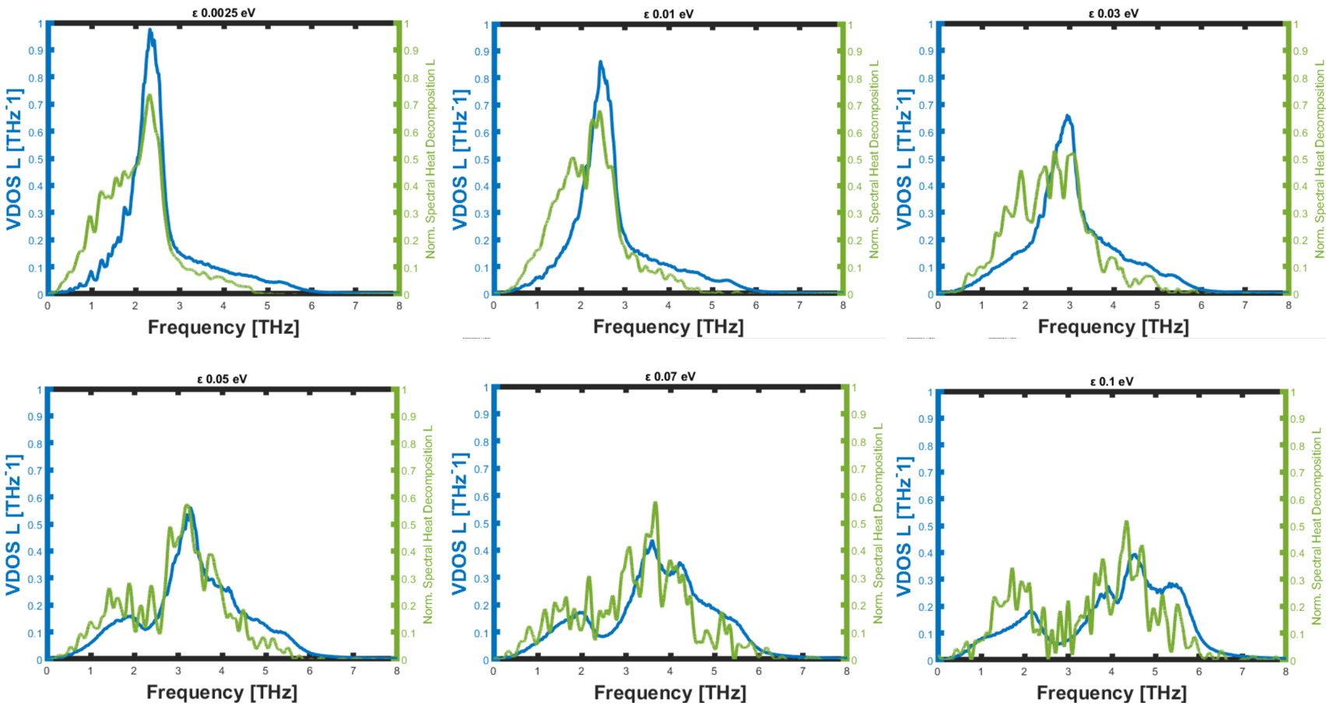**Fig 3: (top) MEO overlap for transverse modes with raw plots on right; (bottom) MEO overlap for longitudinal modes with raw plots on right.**